# Connecting to your Cloud Server using AWS

**STEP 1**

Connect to AWS education with the university email.

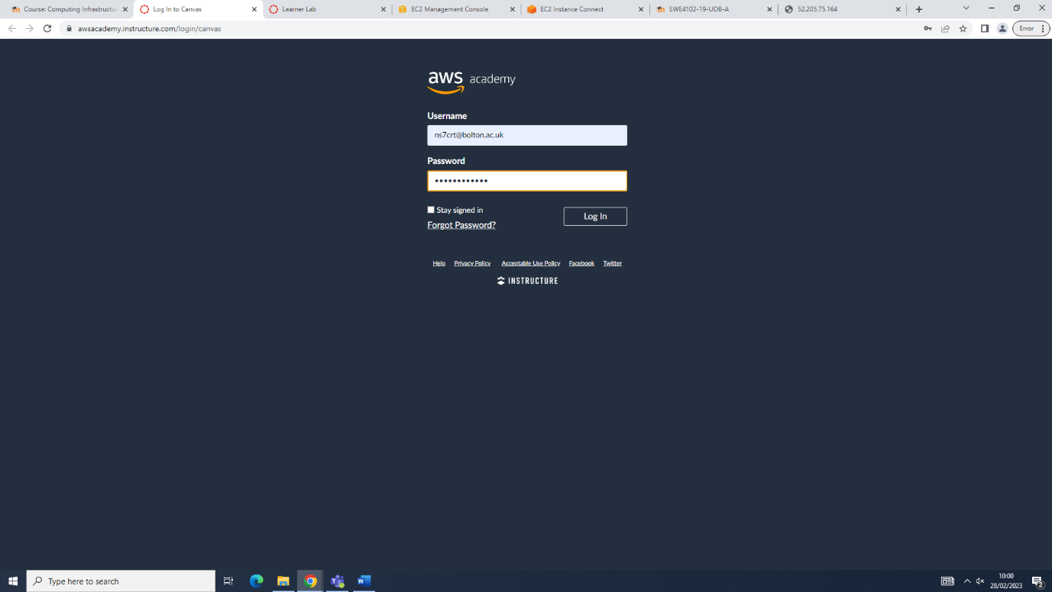

**STEP 2**

After logging in, click on AWS.

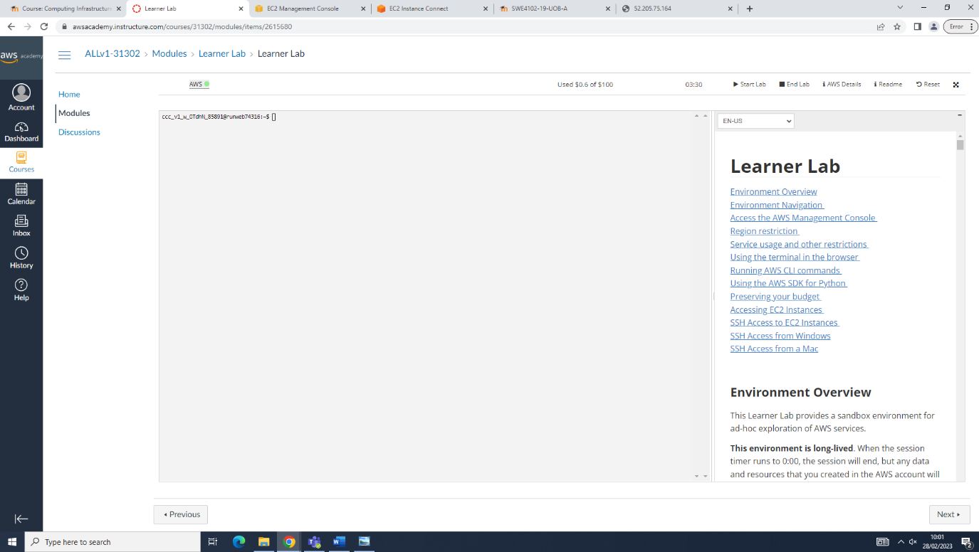

**STEP 3**

Launch a virtual machine to set up the web server.

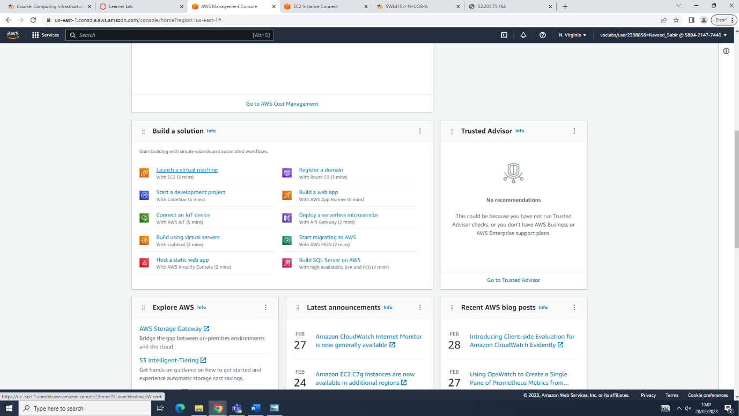

**STEP 4**

Choose the system to launch, in this case its Ubuntu.

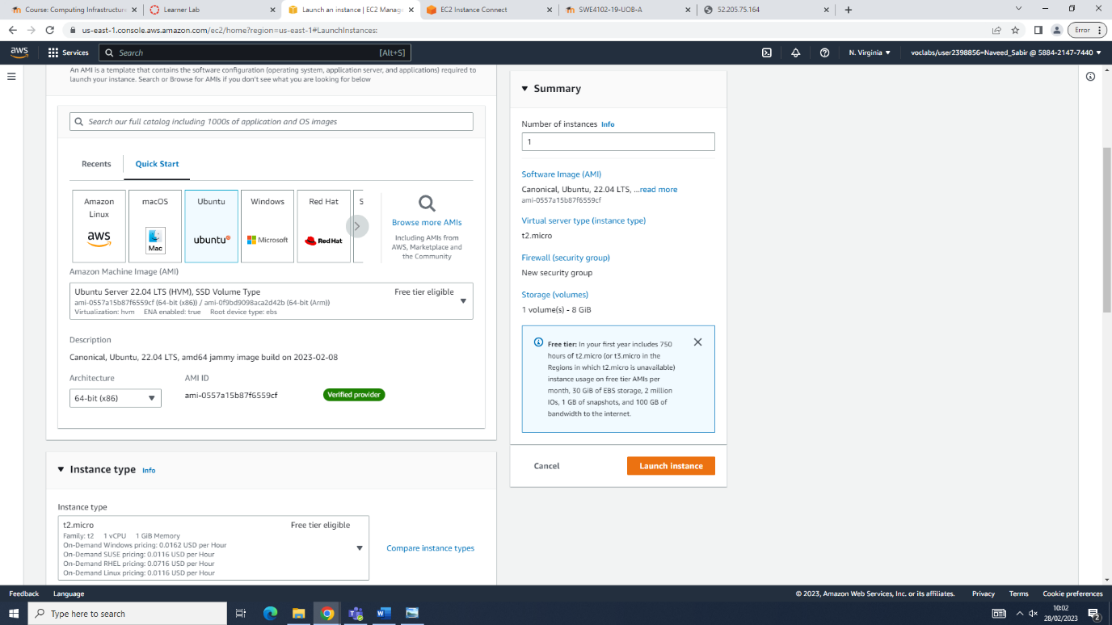

**STEP 5**

Create a key and download it can be added later on if using putty. In this case, putty was not used, instead, the connection was initialized from the AWS prompt provided.

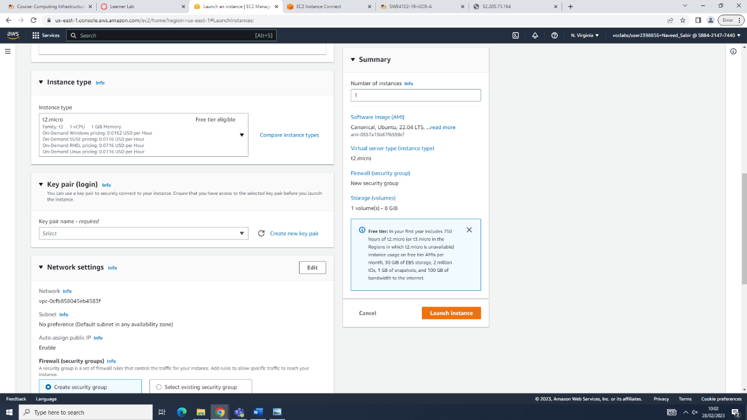

**STEP 6**

Key added as shown below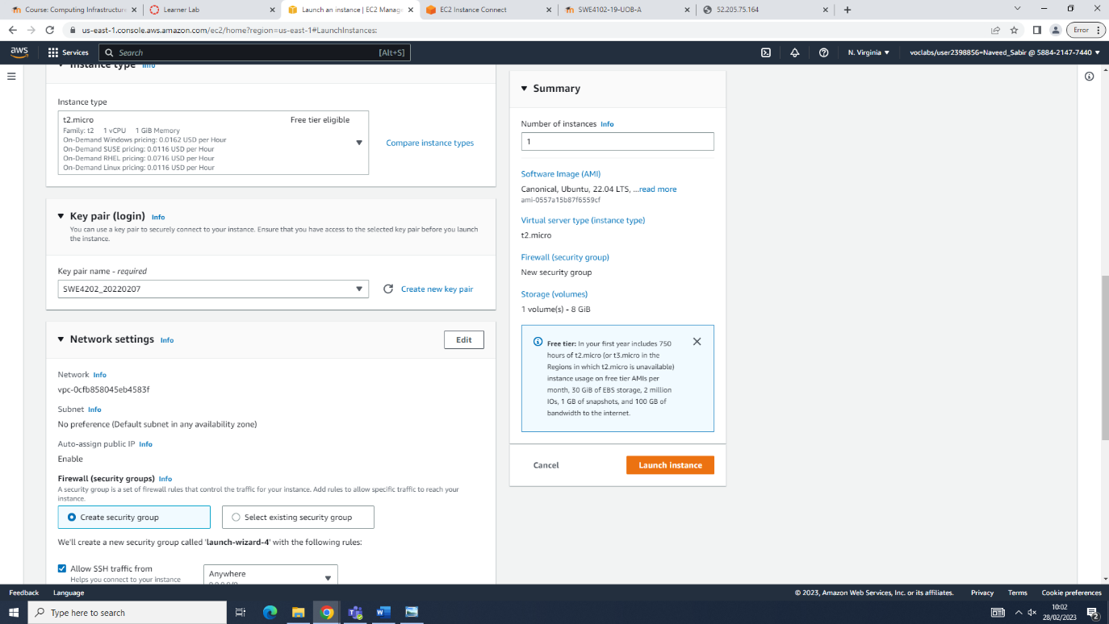.

**STEP 7**

The rest of the settings are the same in this case.

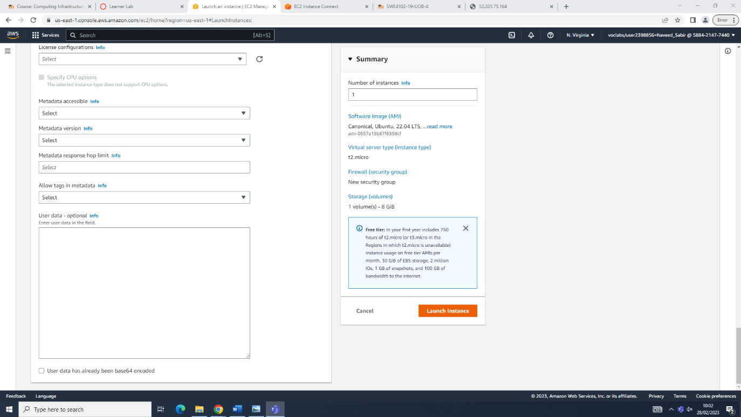

**STEP 8**

View all instances so the information can be taken.

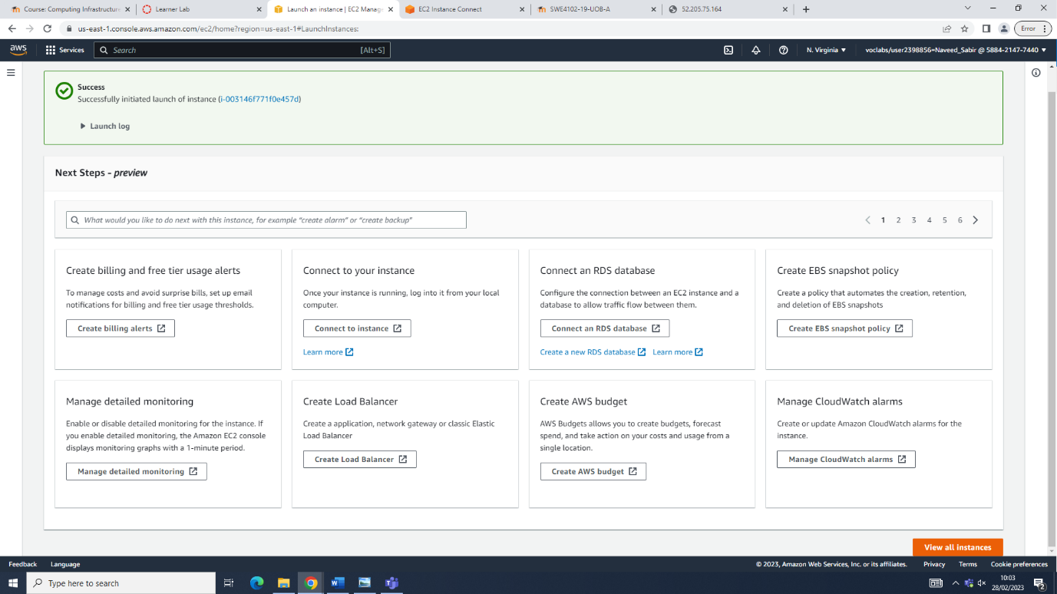

**STEP 9**

Choose the connection.

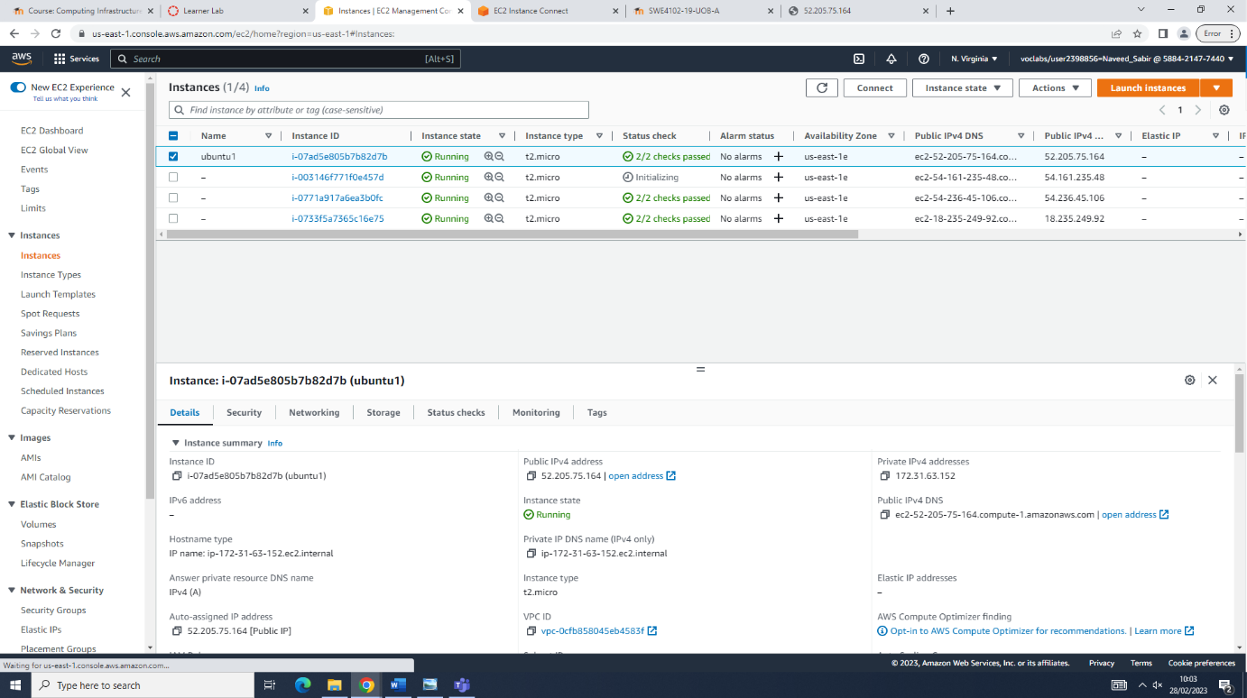

**STEP 10**

Check the IP addresses and connect to the commands prompt.

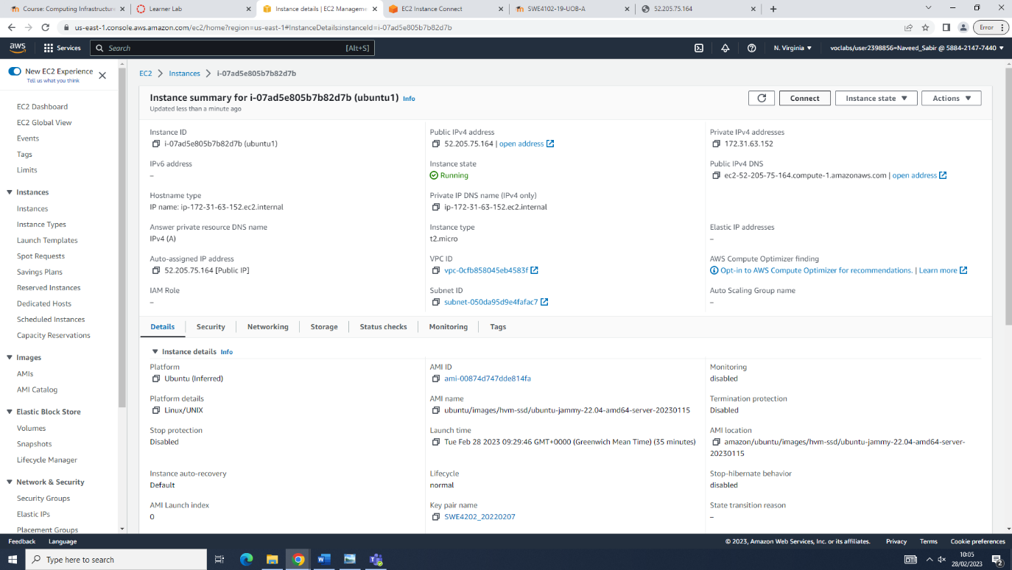

**STEP 11**

Connecting by clicking connect.

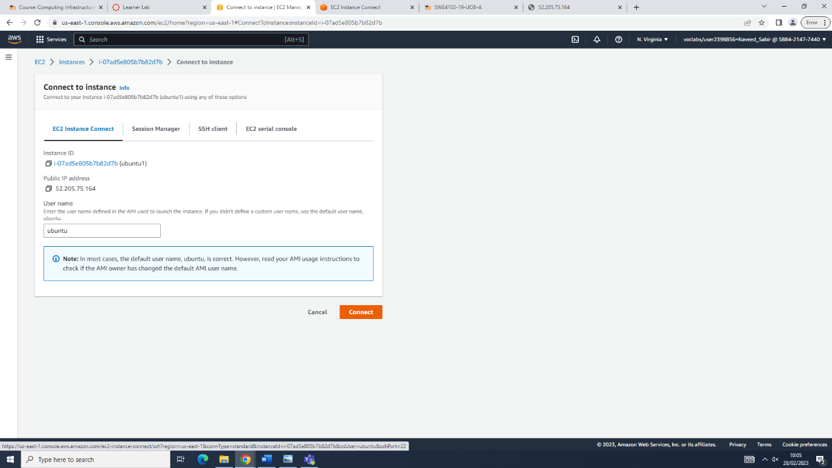

**STEP 12**

Once the command prompt in AWS in open, check the connections and if the server is active with the sudo commands.

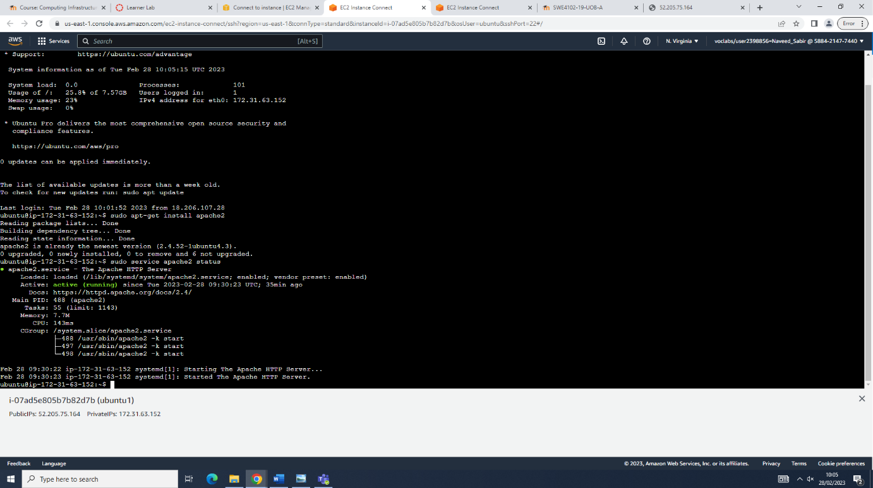

**STEP 13**

After everything is ready, create the website with sudo commands and all the commands to edit, delete or read.

Once everything is done, use the public id of the server in the browser and view the progress and changes of the website.

